**Exploring Air Pollution Externalities in the Peenya Industrial Area, Bengaluru: A Qualitative Study**

A Research Manuscript Submitted in Partial

Fulfillment of the Requirements for the Award of

the Degree of Bachelor of Arts

in

Economics. Political Science, Sociology

Gayathri S

2130782

Under the Guidance of

Dr Greeshma Manoj

Associate Professor



DEPARTMENT OF ECONOMICS

CHRIST (Deemed to be) UNIVERSITY

MARCH 2024

**APPROVAL OF RESEARCH MANUSCRIPT**

The research manuscript titled Exploring Air Pollution Externalities in the Peenya Industrial Area, Bengaluru: A Qualitative Study by Gayathri S, Reg.No.2130782, is approved for the Degree of Bachelors in Economics, Political Science and Sociology.

Supervisor:__________________________________________

Seal

Date:  
Place: Bengaluru

**DECLARATION**

I, Gayathri S , do hereby declare that the research manuscript, entitled ‘Exploring Air Pollution Externalities in the Peenya Industrial Area, Bengaluru: A Qualitative Study’ has been undertaken by me for the award of the Degree of Bachelor of Arts in Economics, Political Science, Sociology. I have completed this study under the supervision of (Faculty, designation) at Department of Economics, CHRIST (Deemed to be University). I also declare that this research manuscript has not been submitted for the award of any degree, diploma or fellowship or any other title in this University or any other university. It has not been sent for any publication or presentation purpose. I hereby confirm the originality of the work and that there is no plagiarism in any part of the research manuscript. I also declare that any errors or misrepresentation of any facts encountered from the study will solely be my responsibility.

Date:

Place: Bengaluru

Gayathri S

Register No. 2130782

Department of Economics

CHRIST (Deemed to be University)

Bengaluru

**CERTIFICATE**

This to certify that the research manuscript submitted by Gayathri S (Reg Number 2130782) titled ‘Exploring Air Pollution Externalities in the Peenya Industrial Area, Bengaluru: A Qualitative Study’ is a record of research work done by her during the academic year 2023-24 under my guidance and supervision in partial fulfilment for the award of Bachelors in Economics, Political Science, Sociology. This research manuscript has not been submitted for the award of any degree, diploma, or fellowship or any other title in this University or any other university. It has not been sent for any publication or presentation purpose. I hereby confirm the originality of the work and that there is no plagiarism in any part of the research manuscript.

Date: Dr Greeshma Manoj

Place: Bengaluru Associate Professor

Department of Economics

CHRIST (Deemed to be University)

Dr. Joshy K J

Head of the Department

Department of Economics

CHRIST (Deemed to be University)

Bengaluru

**ACKNOWLEDGEMENT**

The completion of this research manuscript is realized due to efforts and support from many

people. It is these people I owe my deepest gratitude to. First and foremost, I am extremely

thankful to my supervisor for her valuable guidance and support. Her attention

to detail has truly allowed me to overcome minutest error and improve the quality of my work.

I would like to extend thanks to Dr Greeshma Manoj for her constant assistance and guidance. She was

the constant source of motivation and support for me. I also, sincerely thank all faculty

members of Department of Economics, who made relevant and important suggestions during

the various stages of the study. The intellectual inputs provided by my supervisor and the

faculty of the Department of Economics have been truly enriching.

I take this opportunity to sincerely thank my parents, siblings and my extended family for their

constant motivation and emotional support to complete this academic challenge. My fellow

classmates who were a part of my journey, made the three years smooth and hasslefree. I express

my gratitude to the management of CHRIST (Deemed to be University), for providing the

students with an excellent infrastructure and resources without which, I would not have gained

the knowledge I did during the completion of this research manuscript.

Last and most importantly, I would like to thank the Almighty, for the abundance of blessings. I

am extremely indebted to God for giving me mental strength and ability that makes me

overcome every challenge posed to me.

**Gayathri S**

**ABSTRACT**

Bengaluru, known as the Silicon Valley of India, has an estimated population of 13,607,800. Extensive population growth, migration, and expansion have resulted in urban sprawl and landscape fragmentation in and around Bengaluru . The expanding population and rapid urbanization pose a significant threat to the city's environmental well-being. Worldwide, air pollution is recognized as the fourth leading risk factor associated with deaths .In Bengaluru, this concerning trend continues as the city faces air pollution as a prominent threat. Particulate Matter (PM) 2.5, PM10, and Nitrogen Dioxide have spiked to alarming levels. The major contributors to PM pollution in Bengaluru are emissions from transportation, industries, open waste burning, and domestic cooking. Underpinning the concern is the fact that the increasing population can have adverse effects on public health, leading to a higher prevalence of respiratory diseases among the citizens. Pollution is a negative externality, and hence there is a social cost associated with it. The rising number of premature deaths, increased health expenditures, changes in labor productivity, and higher rates of absenteeism are a few of the social costs that come along with air pollution. In Peenya, there are widespread worries about air pollution, primarily from vehicle emissions and industrial activities, prompting demands for improved government actions and stricter regulations to reduce pollution and protect public health.

## 

## **INTRODUCTION**

Air pollution is a pervasive environmental issue that arises from the release of harmful substances into the atmosphere, leading to adverse effects on human health, ecosystems, and the climate. It encompasses a range of pollutants, including particulate matter[1], nitrogen oxides[2], sulfur dioxide[3], ozone, and volatile organic compounds, emitted from various sources such as vehicles, industrial facilities, and agricultural activities. Despite efforts to mitigate its impacts, air pollution remains a significant global challenge, with profound implications for public health and the environment. Addressing this complex issue requires interdisciplinary approaches, effective policies, and international cooperation to reduce emissions and safeguard air quality for present and future generations. Outdoor air pollution has a significant environmental health challenge impacting individuals across a spectrum of economic statuses, spanning low-, middle-, and high-income countries. In 2019, ambient (outdoor) air pollution, prevalent in both urban and rural areas, was linked to approximately 4.2 million premature deaths annually worldwide. These fatalities result from exposure to fine particulate matter, contributing to the onset of cardiovascular and respiratory illnesses as well as certain cancers (WHO, 2022).

In 2018, the total economic burden amounted to approximately 2.9 trillion USD, equivalent to 3.3% of the global Gross Domestic Product (GDP). This financial impact is particularly pronounced in nations characterized by elevated air pollution levels and significant rates of chronic disease incidence and mortality (Centre for Research on Energy and Clean Air, 2020)

As per a report from the World Bank, the global cost of health problems due to air pollution is estimated at $8.1 trillion, representing 6.1% of the world's GDP. The substantial economic effects of air pollution emphasize the importance of investing in measures to manage air quality and control pollution (World Bank 2022)**.** Air pollution is associated with the development of long-term respiratory conditions such as asthma, bronchitis, and chronic obstructive pulmonary disease (COPD). Extended exposure to air pollution may also lead to cardiovascular disorders, including hypertension, heart attacks, and strokes (Manisalidis et al., 2020). Air pollution results in substantial mortality, with around 1.67 million deaths attributed to it in India in 2017, making up 17.8% of the total deaths in the country (Kaur & Pandey. 2021).

The present PM2.5 levels in India exceed the recommended limit set by WHO's 24-hour air quality guidelines by 5.3 times. Bengaluru's current air pollution level is moderate. (India Air Quality Index (AQI)).

Peenya Industrial Area/Estate in Bengaluru stands as one of the most ancient and extensive industrial zones in Southeast Asia. Formed in the late 1970s by the Karnataka Small Industries Development Corporation (KSSIDC) in three stages (Stage I, II, and III), the estate expanded further with the development of Industrial Areas in Phases I, II, III, and IV by the Karnataka Industrial Area Development Board (KIADB). The total area spans approximately 40 square kilometers, situated in the north-western outskirts of Bengaluru city . Currently, the complete industrial area and estate fall under the jurisdiction of Bruhat Bangalore Mahanagara Palike (BBMP). The entire region is designated as an industrial zone according to the Comprehensive Development Plan (CDP) of Bengaluru, as declared by the Bangalore Development Authority (BDA) until the year 2015, and this designation is still in effect. Industries with notable pollution impact include surface treatment activities like galvanizing, pickling, phosphating, anodization, electroplating, degreasing, textile dyeing, garment washing, lead processing, spray painting, powder coating with a seven-tank process, and pharmaceuticals formulations, among others (CPCB). Bengaluru's Peenya Industrial Area has been identified as highly polluted, and the Karnataka State Pollution Control Board has officially designated it as such.

The Comprehensive Environmental Pollution Index (CEPI), developed by the Central Pollution Control Board (CPCB), assesses the environmental impact of industrial clusters nationwide. Based on this index, 43 industrial clusters with a CEPI greater than 70 (on a scale of 0 to 100) have been identified as critically polluted. CEPI scores encompass dimensions such as air, water, and land quality, providing a rational measure of environmental conditions using the source-pathway-receptor algorithm (CPCB). Peenya Industrial Cluster has been designated as a highly polluted region, ranking 32nd with an overall CEPI score of 65.11 and 56.75 for air (KSPCB, 2020). As a result, the Peenya Industrial Area in Bengaluru was designated as a Severely Polluted Area in the state of Karnataka by the Ministry of Environment and Forests (MoEF) on January 13, 2010 (MoEF, 2014).

## **LITERATURE REVIEW**

Externalities, as defined by Ekelund et al. (2006), encompass the positive or negative effects of an individual's actions that are not directly experienced or borne by that individual. Developing countries bear the brunt of both household air pollution, stemming from the use of biomass fuels for cooking, and environmental pollution from industrial and transportation activities (Das et al., 2022).

Bengaluru, one of India's prominent urban centers, hosts a substantial population exceeding 12 million individuals. Alongside this sizable populace, the city boasts a notable vehicular presence, with an estimated 6.7 million vehicles navigating its streets (Doravari, A., & Bhardwaj, M., 2023). The varied composition of vehicles and the high volume of traffic make a substantial contribution to vehicular emissions in Bengaluru. These emissions consist [4]of a combination of pollutants such as nitrogen oxides (NOx), carbon monoxide (CO), and particulate matter (PM), which have a notable impact on the city's air quality (Ramachandra et al., 2020).

According to the annual report released by the Department of Transport Bengaluru, the majority of the city's vehicular population comprises two-wheelers (69%) and privately owned cars (20%), collectively constituting 90% of the total vehicles. This data suggests two key observations: Firstly, it reflects the city's growth and the increasing need for residents to commute for their daily civic needs. Secondly, it indicates a lack of efficient public

transportation options, as a significant portion of the population relies on personal vehicles for commuting (Thakur, 2017).

Bengaluru, a South Indian inland city, was also labeled as one of the non-attainment cities due to its high particulate pollution levels (Prabhu et al., 2022). This designation stems from the city's failure to meet the National Ambient Air Quality standards (Central Pollution Control Board, n.d.). In 2019, the number of deaths attributable to air pollution in India was 1.6 million, accounting for 17.8% of the total deaths in the country (Pandey et al., 2021).

From an economic perspective, air quality is considered a public good with positive and negative externalities. As highlighted by Baumol and Oates (1988), Goulder and Parry (2008), and Cahoon et al. (2020), air pollution represents a negative externality due to the lack of pricing mechanisms for air quality, leading to inefficient allocation. In urban and industrial environments, air pollution and declining air quality are primarily attributed to several significant ambient air pollutants, including nitrogen dioxide (NO2), nitric oxide (NO), sulphur dioxide (SO2), and particulate matter (PM2.5 and PM10) (Gouda et al., 2021).

Air quality monitoring (AQM) plays a crucial role in evaluating air pollution levels and their effects on human health, the environment, and biodiversity (Kumar et al., 2019). However, the rapid increase in vehicle registrations, with around 1,750 new vehicles registered in the city every day, has led to a vehicle population in Bengaluru that surpasses 80.45 lakh vehicles, five times higher than the official capacity of Bengaluru roads. Consequently, the city has surpassed Mumbai, Hyderabad, and Chennai in vehicle density (Siddika et al., 2016). This surge in vehicles has caused a significant reduction in traffic speeds, slowing them down to approximately 10 kilometers per hour (Indira et al., 2023).

To address and mitigate air pollution, the Air (Prevention and Control of Pollution) Act was enacted in 1981. According to Section 2(b) of this Act, 'air pollution' is defined as the presence of any air pollutant in the atmosphere. Similarly, Section 2(a) defines an 'air pollutant' as any solid, liquid, or gaseous substance, including noise, present in the atmosphere at concentrations that could harm human beings, other living creatures, plants, property, or the environment. Therefore, ambient air quality standards serve as policy guidelines aimed at regulating the impact of human activities on the environment, thereby controlling pollutant emissions into the air (CPCB, 2020).

The national standards set for ambient air quality regarding sulfur dioxide (SO2) is 50, Nitrogen Oxide (NO2) is 40, Particulate Matter PM10 is 60, Particulate Matter PM2.5 40 for Industrial areas as given by the CPCB. With more than 2,000 establishments within its vicinity, the Peenya industrial hub has been designated as a significantly contaminated zone and ranks 32nd in terms of pollution levels (Kajal, 2020). The proportion of urban built-up area within each city serves as a crucial predictor variable for the level of particulate pollution in the city (Sarret et al). In 2020, the cumulative built-up area expanded to 867.73 square kilometers, constituting 39.70% of the total area of Bangalore. There is a noticeable upward trend in urban built-up areas from 2001 to 2021, with an impressive growth rate of 87.62% over the span of 20 years (Kanga et al., 2022).

Perception of environmental pollution entails how individuals perceive the presence of pollution in their surroundings (Zhu & Lu, 2023). Research on public perceptions of air pollution, which focuses on the subjective judgments and understanding of the general public regarding its causes, severity, and impacts, often utilizes surveys or attitude polls. These methods offer valuable insights into public attitudes, contrasting with objective data or expert opinions, thereby serving as influential references for shaping and enacting public policies concerning air pollution. Since the middle of the twentieth century, numerous surveys and studies have been conducted on this topic, yielding significant and fruitful research outcomes (Saksena, 2012).

## **RESEARCH GAP**

Limited attention has been given to exploring residents' perceptions and concerns regarding air pollution in the Peenya Industrial Area of Bengaluru, particularly focusing on their subjective experiences and attitudes towards air quality issues. While some studies may have investigated objective measures of air pollution levels, there remains a need for research into the nuanced perspectives of individuals living in proximity to industrial activities. Addressing this aspect could provide valuable insightsinto the socio-cultural dimensions of air pollution perception and contribute to more holistic strategies for mitigating pollution and promoting community well-being in industrial areas.

## **RESEARCH OBJECTIVES**

* Investigate the potential implications of air pollution in the Peenya Industrial Area, focusing on its effects on public health, environmental quality, and community well-being.
* Examine the prevalent concerns and perceptions regarding air pollution among residents specifically residing in the Peenya industrial area of Bengaluru.

## 

## 

## 

## **STUDY AREA**

**Figure 1** depicts the outline of the Peenya Industrial area, chosen as the focal point of the study due to its dense concentration of industries and the significant presence of an important highway traversing through this locality.

**Fig. 1 Map showing Peenya industrial area**

**Source: KSPCB**

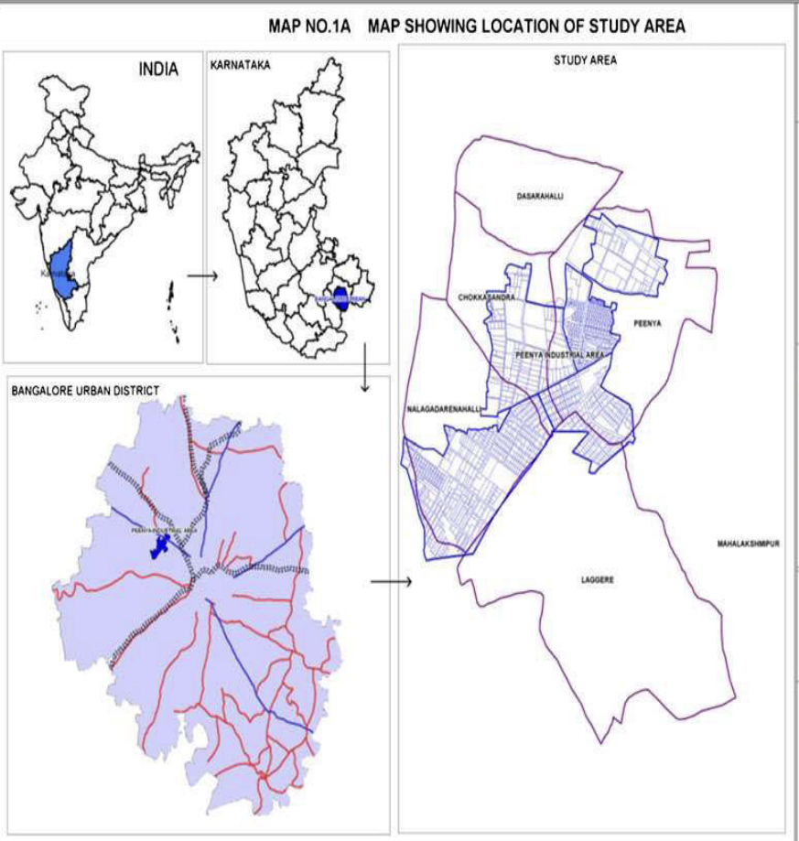

1. **RESEARCH METHOD**

This section presents the method employed in conducting the research study. A semi-structured questionnaire was used to gather qualitative data from the study's sample of fifteen participants. Stratified Random sampling was used, but it was restricted to the area of study which was Peenya Industrial Area, Bengaluru hence the sampling technique used was Stratified random sampling. Stratified random sampling was employed, focusing solely on respondents from the Peenya area for interview selection. The medium of data collection was in Kannada which were later transcribed in English.Adding on to this, a structured questionnaire for Likert scale analysis was employed to gauge perceptions regarding air pollution in Peenya, with a sample size of 40 respondents. This process was applied exclusively to the primary data. In addition to primary data, secondary data was used to establish the presence of air pollution as an externality in the area of study. To substantiate this aspect of study Spatio-temporal data in the form of images and data from official government sources such as the Central Pollution Control board (CPCB) and Karnataka State Pollution Control Board (KSPCB) were utilized.

1. **DATA ANALYSIS**

**Fig2 Map denoting the Air quality monitoring stations in Bengaluru**

**Source: KSPCB**

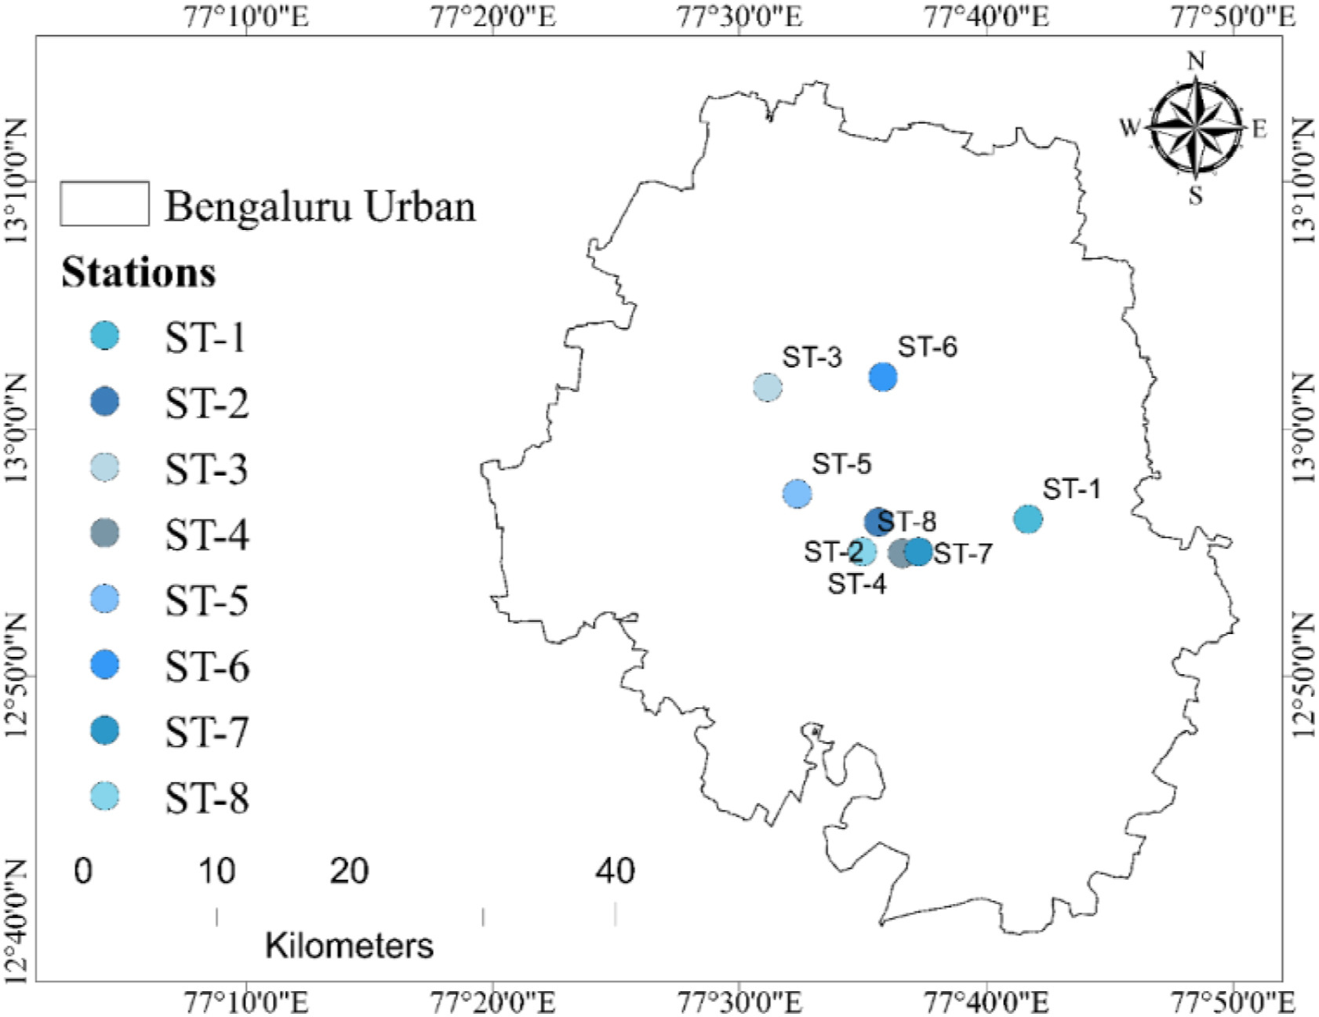

**Table1 List of Air quality monitoring stations in Bengaluru**

**Source: KSPCB**

| **Station Number** | **Station Name** |
| --- | --- |
| ST 1 | BWSSB Kadubesanahalli |
| ST 2 | Hombegowda |
| ST 3 | Peenya Zone |
| ST 4 | BTM Layout |
| ST 5 | Bapuji Nagar |
| ST 6 | Hebbal Area |
| ST 7 | Silk Board Area |
| ST 8 | Jayangar 5th Block |

**Figures 4,5,6,7,8,9** depict the spatio-temporal images of the pollution concentration in eight air quality monitoring stations in Bengaluru. As shown in **figure 2** and correspondingly in **table 1,**  **ST-3** represents Peenya zone station where emissions in Peenya are monitored regularly.

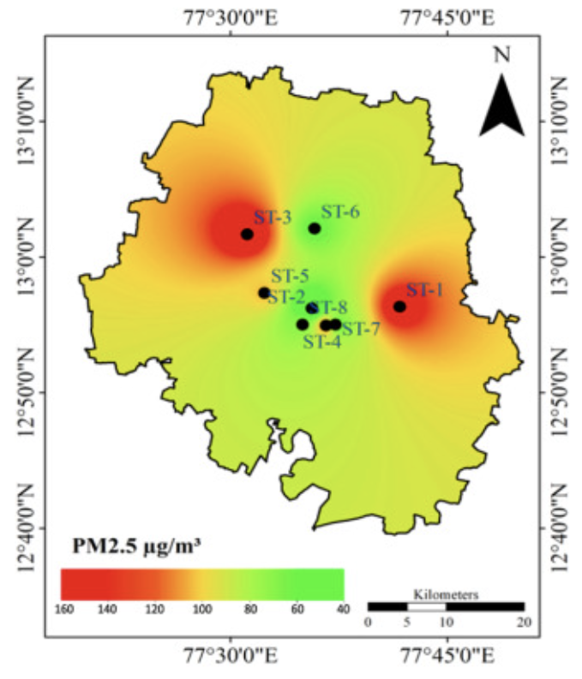 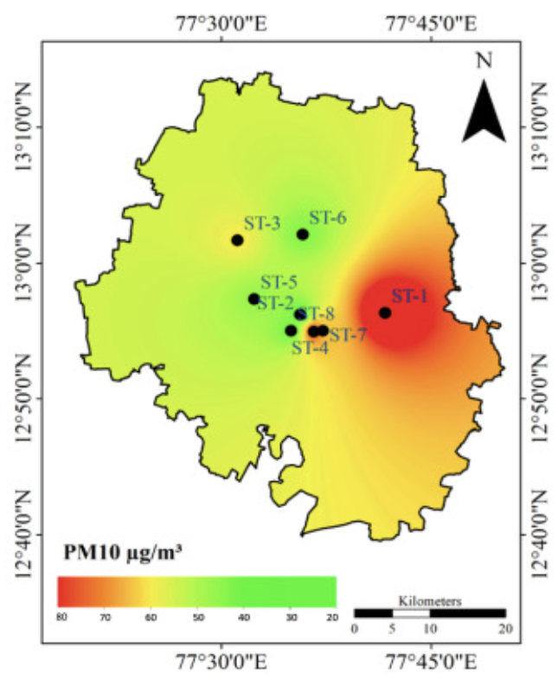

**Fig. 4 PM 2.5 Fig. 5 PM 10**

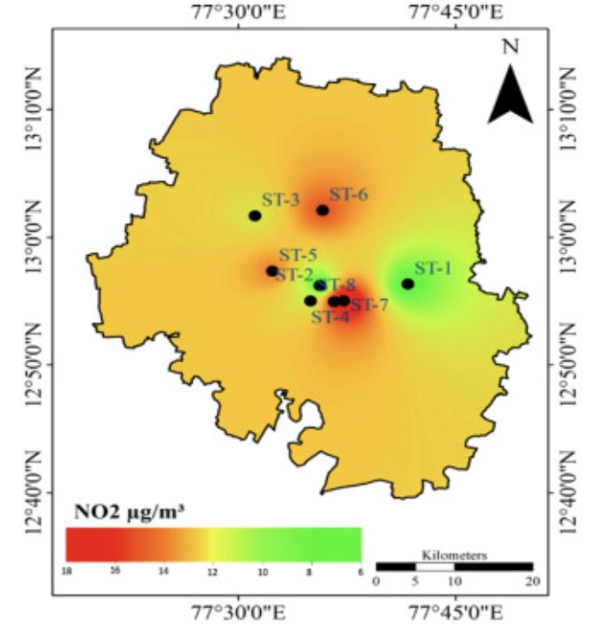 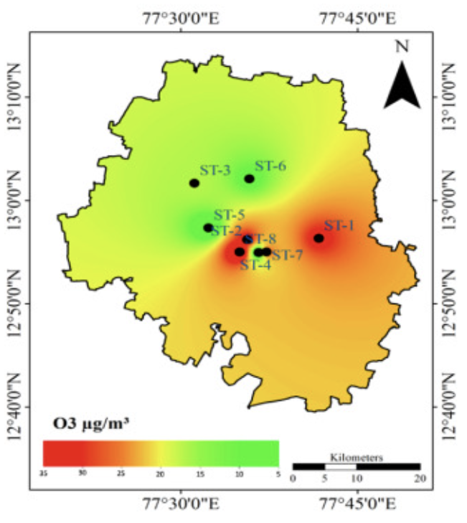

**Fig. 6 NO2 Fig. 7 O3**

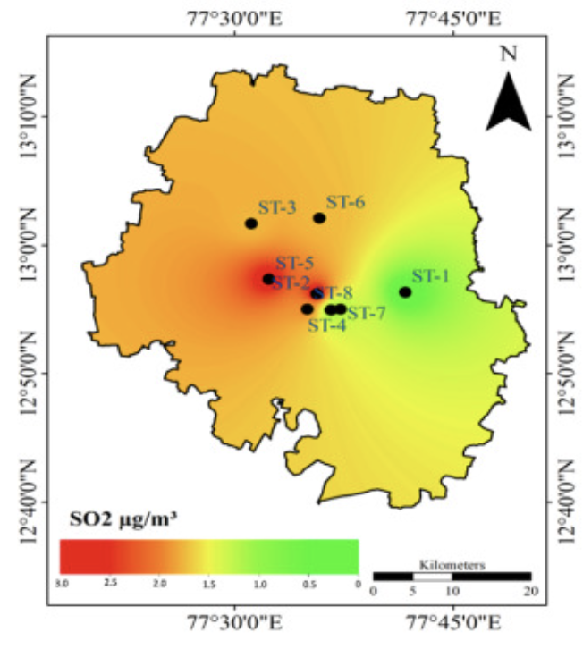 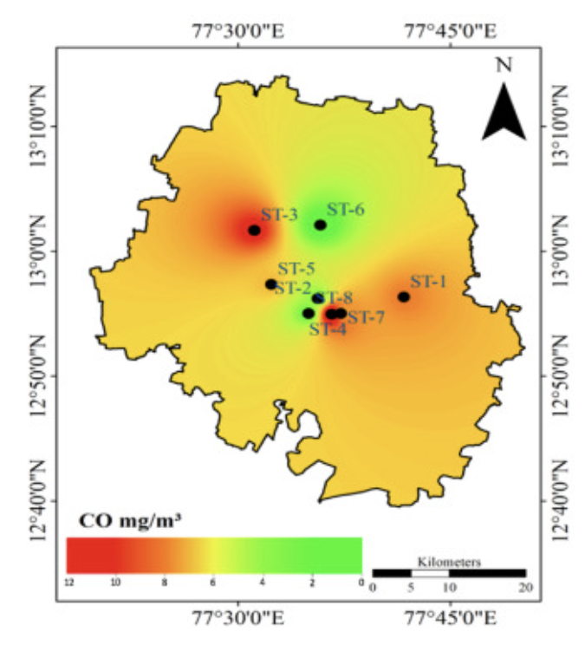

**Fig. 8 SO2 Fig . 9 CO**

**Source:** [**https://doi.org/10.1016/j.nhres.2023.10.002**](https://doi.org/10.1016/j.nhres.2023.10.002)

**Fig10 Average annual air pollution in Peenya**

**Source: CPCB Annual report 2019-2020**

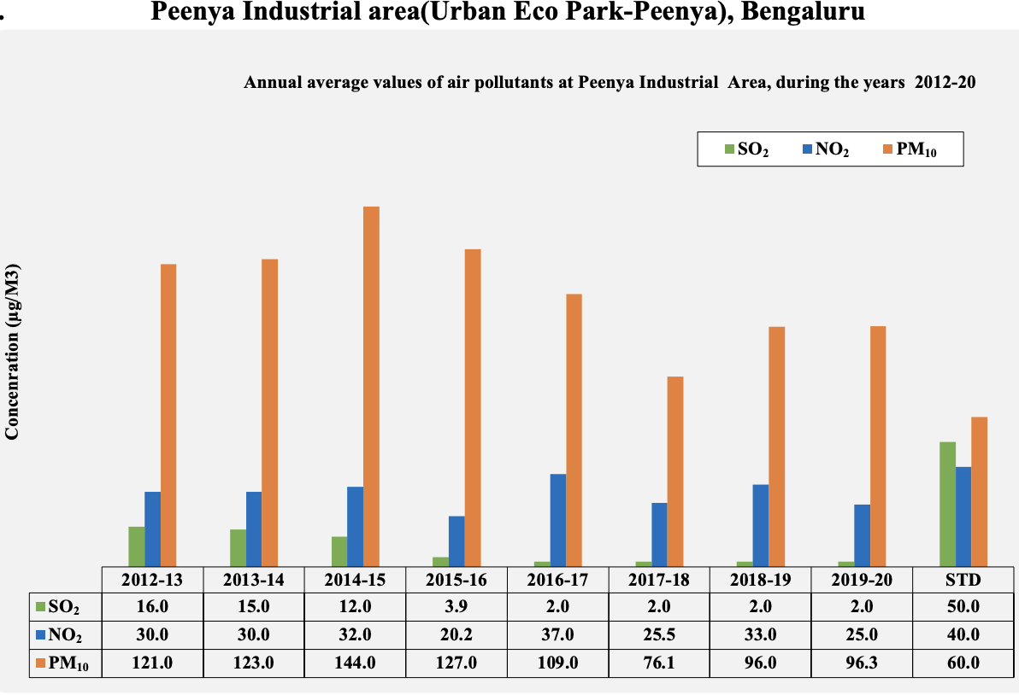

A thematic analysis, based on word frequency analysis, was conducted to identify recurring themes and patterns in the qualitative responses obtained from the participants.

The analysis focused on the frequency of keywords related to air pollution and related concerns.

This section aims to understand the prevailing themes and subjects associated with the research field by examining the word frequency data derived from the qualitative replies. Word frequency analysis is a basic method for locating recurrent words and ideas, offering a quick overview of the major themes found in the dataset.

1. **RESULTS**

The spatio-temporal image in **Figure 9** and **Figure 4** show extreme concentrations of Carbon Monoxide (CO) and Particulate Matter (PM2.5) respectively. Many epidemiological and toxicological investigations frequently consider ambient fine particulate matter (PM2.5), which refers to particles with a diameter of less than 2.5 µm, as a substantial potential threat to human health. PM2.5 is primarily ingested through the respiratory tract, penetrating lung alveoli and entering the bloodstream. Based on the latest data available, fine particulate matter, known as PM2.5, contributes to approximately 4 million deaths worldwide due to cardiopulmonary diseases, including heart ailments, respiratory infections, chronic lung conditions, cancers, premature births, and other health issues (Thangavel et al., 2022). Carbon monoxide (CO) is a hazardous, transparent gas produced from the insufficient burning of coal and various petroleum-based substances predominantly within the industrial domain(Bahng et al., 2021). Typical sources of carbon monoxide (CO) in work environments encompass fuel-operated machinery (such as vehicles, forklifts, generators, and pumps), as well as heating systems reliant on fuel combustion (including furnaces, water heaters, boilers, and space heaters), alongside industrial equipment like coke ovens and blast furnaces. Nevertheless, the primary contributors to CO emissions often stem from malfunctioning, improperly serviced, or poorly ventilated gas appliances like stoves and heaters. Exposure to carbon monoxide can lead to significant cardiovascular consequences. Carbon monoxide poisoning heightens the likelihood of experiencing an arrhythmia (Rose & Wang, 2017). **Figure 10** shows the annual average emissions of pollutants PM10, NO2 and SO2 throughout eight years from 2012-2020 in Peenya. Though the level of emissions have decreased, the emissions of SO2 and NO2 have increased drastically.

The following themes emerged while conducting thematic analysis:

**7.1 Air Pollution Concerns**

The thematic analysis exhibited widespread concern among participants regarding air pollution. The frequency of words such as “air” and”pollution” indicates pervasive acknowledgement of the issue’s significance. Participants expressed worry and frustration regarding the deteriorating air quality in their area

**7.2 Health Impacts**

The next prominent theme identified in the analysis is the health impacts of the air pollution in the area of study. The frequent occurrence of terms such as “health” and “issues” suggests that individuals see air pollution as a significant threat to their well-being. In certain instances participants described experiencing respiratory problems, coughing, wheezing, and other issues attributed to poor air quality.

**7.3 Government inaction**

The analysis emphasized a perception of governmental inaction or insufficient measures to address air pollution. The word “government” emerge frequently, indicating dissatisfaction among participation with lack of impactful policies and measures to mitigate the effects of air pollution

**.4 Vehicular Emissions**

Participants recognized vehicular emissions as a major contributor to air pollution in the area of study. The mention of the word “vehicles” frequently calls for stricter regulations on vehicle emissions and advocacy for cleaner transportation alternatives

The growth of Bengaluru has resulted in a rise in the number of vehicles, with an annual growth rate ranging from 7% to 10%. Personal modes of transportation have expanded significantly, with two-wheelers and cars collectively accounting for approximately 90% of the city's registered vehicle population. Among these, two-wheelers constitute over 70%, while cars make up 15%, autos 4%, and the remaining 8% consists of other vehicles such as buses, vans, and tempos (CPCB).

**7.5 Desire for Clean Environment**

A shared desire among participants for a cleaner and healthier environment was expressed in the analysis. Words like “clean” indicated a willingness to take actions and pay for initiatives aimed at improving the quality of air and reducing the levels of air pollution in the area.

**7.6 Call for Government Intervention**

Participants showcased the importance of government intervention in addressing air pollution issues. They called for stronger enforcement of environmental regulations, investments in proactive measures to combat pollution sources such as industrial emissions and open waste burning.

**7.7 Community Health and Well-being**

Overall, the thematic analysis underscored the interconnectedness of air pollution, public health , and environmental well-being.

**Socio-demographic Profile of the Sample**

The socio-demographic profile is based on the age, sex, annual income and educational qualification of the respondents.

**Fig 11 Shows the gender composition of the sample**

**Source: Field Survey**

**Forms response chart. Question title: Gender
. Number of responses: 40 responses.**

As the **figure 11** clearly shows about 95% of the respondents are males and 5% are females. **Fig.12 Shows the age of the respondents**

**Source: Field Survey**

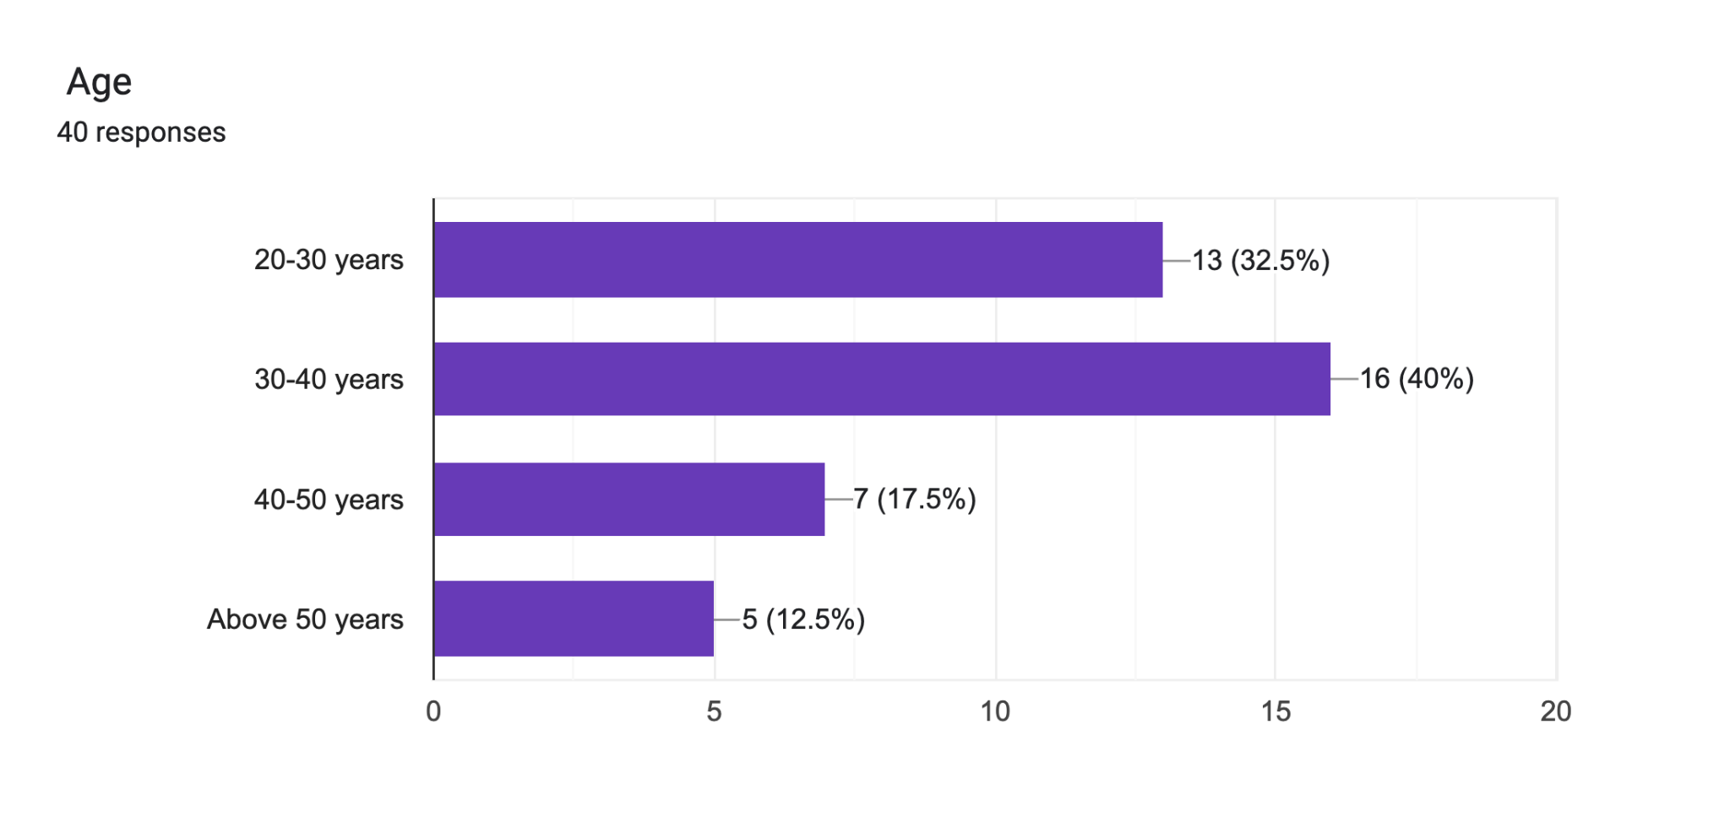

From **figure 12** it is understood that the largest proportion of respondents falls within the age range of 30-40 years, constituting the majority, while approximately 32.5% of participants are aged between 20 and 30 years.

**Fig. 13 Shows the education qualification of the respondents**

**Source: Field Survey**

**Forms response chart. Question title: Education:
. Number of responses: 40 responses.**

**Figure 13** denotes that half of the participants in the study have attained education up to the high school level, while approximately 17.5% have completed primary education.. Around 12.5% of respondents reported having obtained a bachelor's degree.

**Fig.14 Shows the annual income of the respondents**

**Source: Field Survey**

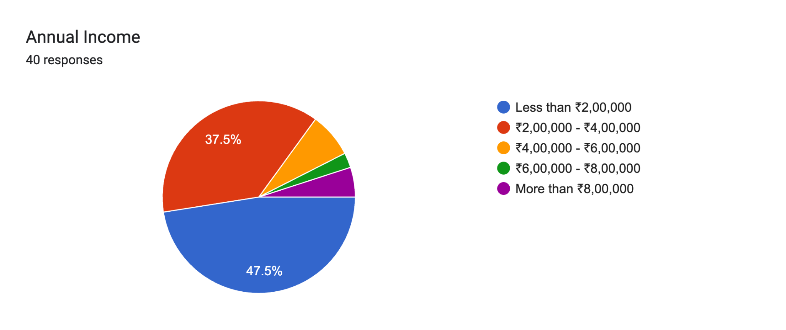

**Figure 14** shows that about 47.5% of the respondents fall in the income category of less than 2,00,000, while around 37.5% of the respondents belong to the income category of 2,00,000 to 4,00,000.

**Fig.15 Reasons for Air pollution**

**Source: Field Survey**

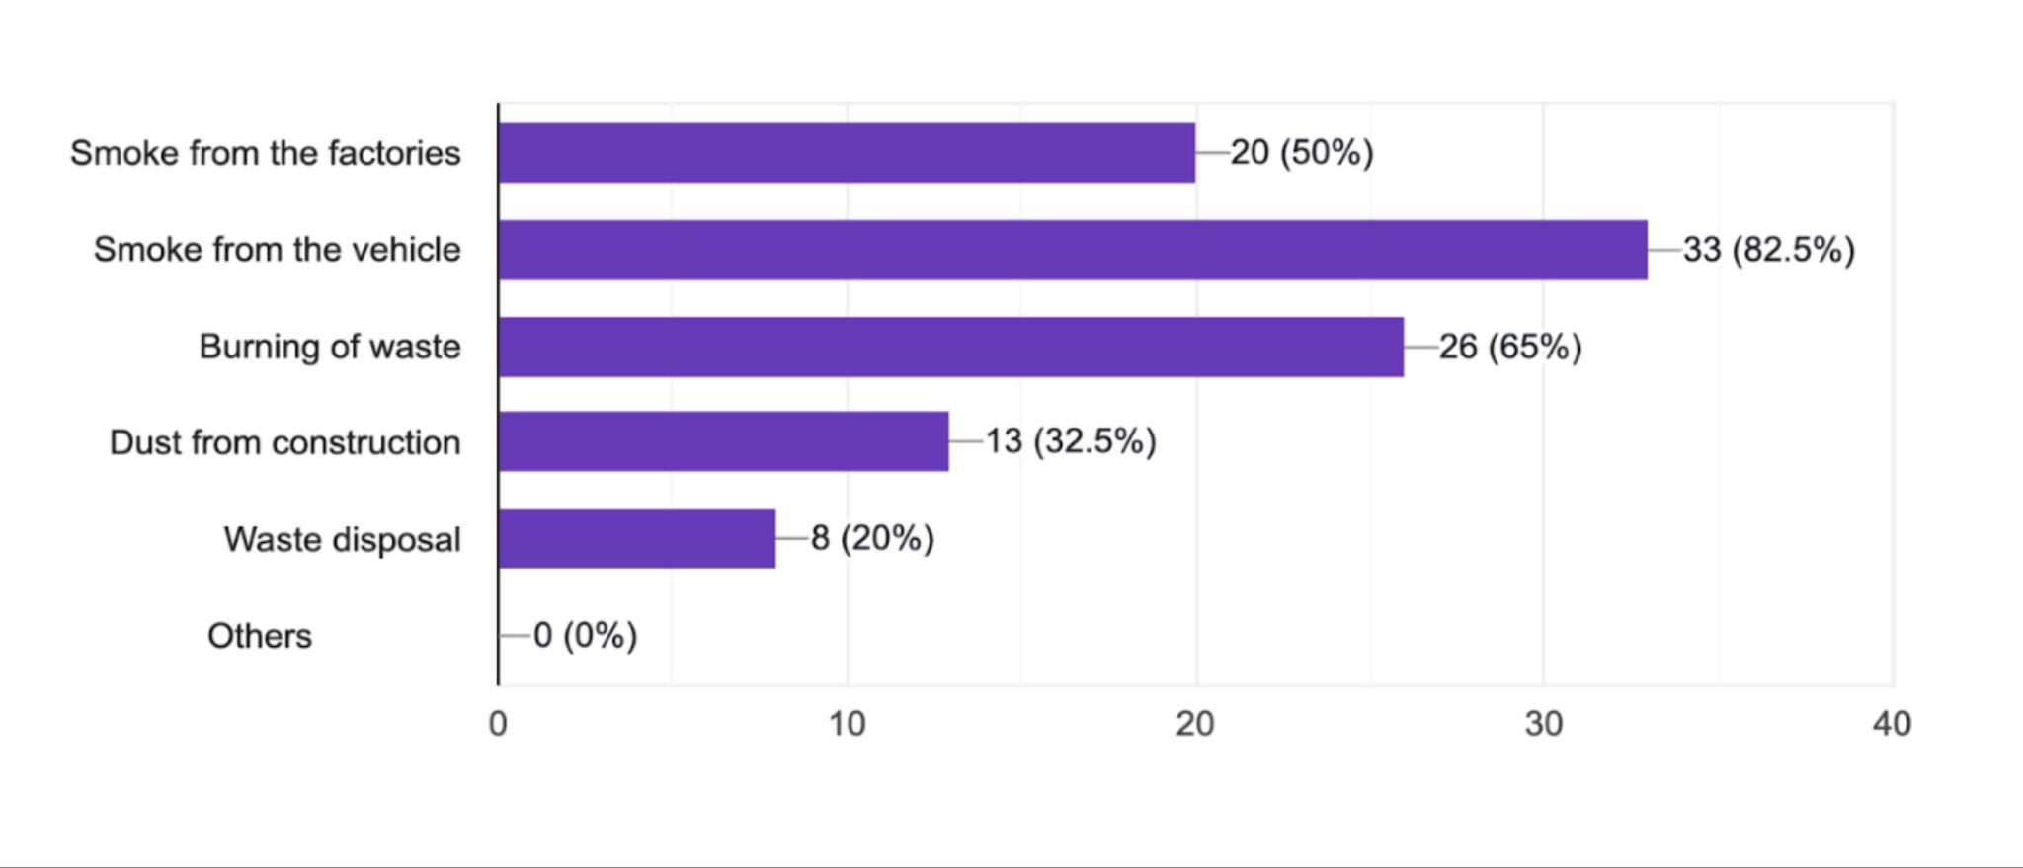

**Figure 15** illustrates that the primary cause of escalating air pollution is attributed to vehicle emissions, with approximately 82.5% of respondents indicating that vehicular emissions play a significant role. Additionally, about 65% of respondents believe that the burning of harmful chemical waste contributes to air pollution in the area under study. It's noteworthy that the question allowed respondents to select multiple options, resulting in cumulative percentages exceeding 100%. For instance, while 20% of respondents highlighted smoke from factories as a significant contributor, this percentage does not represent exclusive responses but rather an additional perspective on factors contributing to air pollution.

**Fig.16 Health issues due to air pollution**

**Source: Field Survey**

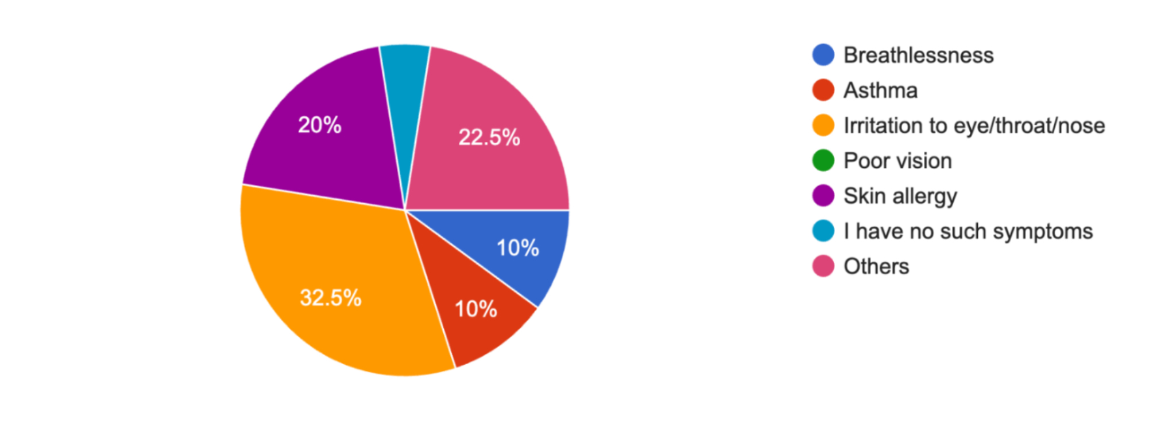

**Figure 16** indicates that about 32.5% of respondents reported experiencing irritation in their eyes, throat, or nose, largely attributed to the elevated levels of PM2.5 in the study area. About 22.5% of the respondents have reported having other health issues such as common cold, cough soot deposits in skin and eye allergies etc. Approximately, 20% of participants cited developing skin allergies from exposure to hazardous chemicals and due to high Ozone concentration levels. 10% of respondents experience breathlessness and Asthma as a result of exposure to carbon monoxide. **Table 2** shows the frequency of responses for each question in the Likert scale.

**Table 2 Frequency of the responses in %**

**Source: Field Survey**

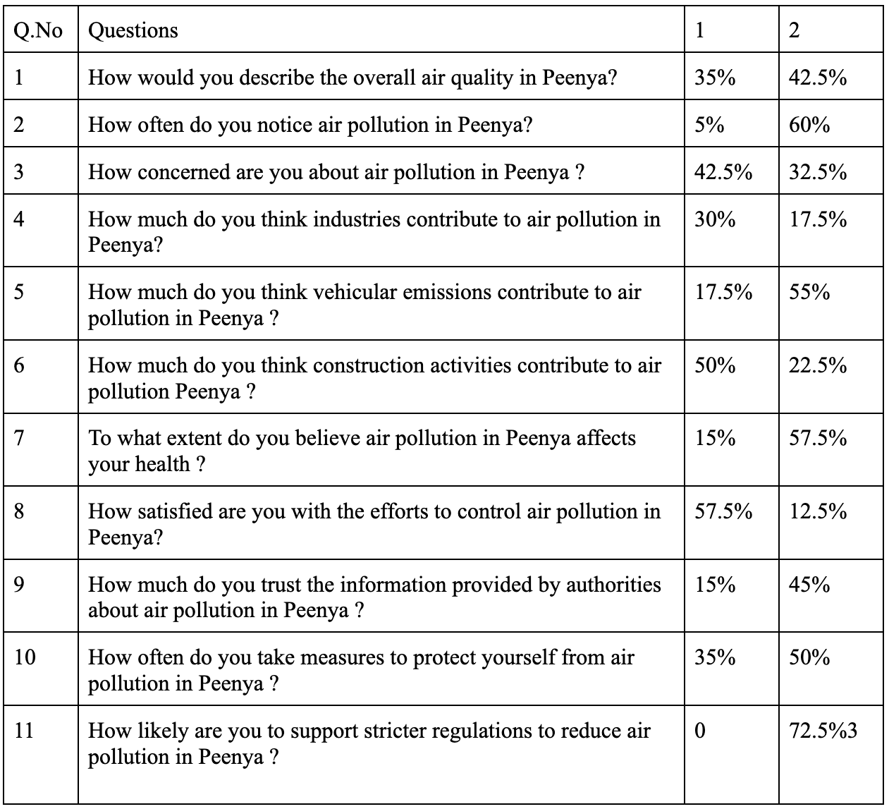

Category 1 in the table shows the response levels in the likert scale from Never to Rarely, Not at all to slightly and Very Dissatisfied to Very Dissatisfied and Category 2 shows response levels such as Frequently to Always, Very Much to Extremely and Satisfied to Very Satisfied.

From **Table 2** about 35% of the respondents perceived the air quality in Peenya as satisfactory, while around 42.4% described it as poor. Approximately 5% of the respondents indicated that they rarely or never notice air pollution, while 60% reported that they frequently or always observe air pollution in the Peenya area. 42.5% of respondents exhibit little to moderate concern regarding air pollution in Peenya, whereas 32.5% express high to extreme levels of concern. This highlights the dilemma faced by low-income groups, where prioritizing basic needs often overshadows concerns about clean air quality. Around 30% of the respondents perceive that industries contribute minimally or not at all to air pollution in Peenya, while 17% opine that industries significantly or extremely contribute to air pollution in the area.

In response to the contribution of vehicular emissions to air pollution in Peenya, 17.5% of respondents indicated that vehicular emissions contribute not at all or to a slight extent, while 55% of respondents stated that emissions from vehicles contribute significantly or extremely to air pollution in the area.

50% of the respondents deny the reason that construction activities contribute to air pollution in the area of study. An overwhelming majority of 57% of respondents believe that their health is affected by the air pollution. It’s important to understand that about 57.5% of the respondents are dissatisfied by the measures taken by the government to address the problem of air pollution in Peenya. However, 45% of the respondents have recorded that they trust the information provided by the government regarding air pollution. A significant number of respondents, approximately 50%, take measures to protect themselves from the effects of air pollution. 72.5% of the respondents have recorded their willingness to support for stricter rules to reduce the air pollution levels in Peenya

The analysis of survey responses reveals significant concerns regarding air pollution in the Peenya area, with vehicular emissions and industrial activities emerging as major contributors. Despite differing views on the sources of pollution, a considerable proportion of respondents express worry about its impact on health and well-being. Consequently, dissatisfaction with government efforts to address air pollution underscores the need for more effective policies and interventions. However, there is a notable willingness among respondents to support stricter regulations aimed at reducing pollution levels. These findings emphasize the pressing need for action to improve air quality in Peenya and emphasize the crucial role of government initiatives in achieving this goal.

## **9. CONCLUSION**

"Air in this area isn't clean; it has been extremely polluted for six to seven years. I haven't had any health issues so far, but I think I will be affected by some health condition very soon." This was the response of one of the participants, indicating the fear induced by the extreme level of air pollution. In developing nations, access to clean air is increasingly perceived as a luxury, with many residents prioritizing employment and basic survival over environmental concerns. The thematic analysis revealed widespread recognition of air pollution as a significant threat to public health and environmental well-being, with particular emphasis on the adverse health impacts attributed to vehicular emissions and industrial activities. The need for stricter Industrial regulations aimed at reducing harmful emissions was revealed through the analysis. Classical literature explores the internalization of externalities either through governmental intervention (Pigou, 1932) or through negotiation between the "polluter" and the "victim" (Coase, 1960). The

The government can impose taxes or subsidies or implement “command and control” to regulate the level of air pollution. It is essential to understand and compute the economic costs associated with air pollution for the purpose of policy intervention by the state. Various techniques such as Cost-of-Illness(COI) method or Willingness to Pay Approach can be used. The findings highlight the importance of addressing air pollution in Peenya and reveal the significance of effective government intervention. Furthermore, respondents' willingness to support stricter regulations suggest a potential direction for mitigating pollution levels in the area. Cooperation between government agencies, industry, and local communities is a compelling need, to combat air pollution and protect public health.

It is evident from the analysis that only about 50% of the respondents are taking measures to protect themselves from the harmful impacts of air pollution. The health protection measures should be initiated by the government such as provision of access to affordable health care, health check-ups at regular intervals for the people living in the area of study. Moreover, people’s concerns regarding air pollution should be included in the decision making process or policy making, to enhance more transparency in local governance. It is imperative that people living in these areas should be made aware of the phenomenon of air pollution and its consequences it can have on them to encourage more responsible behavior towards reducing air pollution, while also protecting themselves from its harmful effects. Awareness about the sources of air pollution and the impact of various pollutants should be made through campaigns and public awareness programmes. By working together to mitigate pollution sources and prioritize clean air initiatives, we can create a healthier and more sustainable environment for generations to come.

**REFERENCES**

1. World Bank. (2022). *The Global Health Cost of PM2.5 Air Pollution: A Case for Action Beyond 2021*. <http://hdl.handle.net/10986/36501>
2. Manisalidis, I., Stavropoulou, E., Stavropoulos, A., & Bezirtzoglou, E. (2020). Environmental and health impacts of air pollution: A review. *Frontiers in Public Health*, *8*. <https://doi.org/10.3389/fpubh.2020.00014>
3. *India Air Quality Index (AQI) : Real-time air pollution level*. (n.d.). Aqi.In. Retrieved January 31, 2024, from <https://www.aqi.in/in/dashboard/india>
4. Kaur, R., & Pandey, P. (2021). Air pollution, climate change, and human health in Indian cities: A brief review. *Frontiers in Sustainable Cities*, *3*. https://doi.org/10.3389/frsc.2021.705131
5. KSPCB. (2020). https://kspcb.karnataka.gov.in/sites/default/files/inline-files/Peenya-3rd%20LAC.pdf
6. CPCB. (n.d.-a). *Action plan for severely polluted peenya industrial area/ estate, Bengaluru, karnataka state prepared by kspcb*. Nic.In. Retrieved January 31, 2024, from <https://cpcb.nic.in/industrial_pollution/New_Action_Plans/CEPI_Action%20Plan_Peenya.pdf>
7. Just, R., Hueth, D., & Schmidt, A. (1982). *Applied Welfare Economics*. Prentice-Hall: New York.
8. Carson, R. T. (2000). Contingent valuation: A user’s guide. *Environmental Science & Technology*, *34*(8), 1413–1418. https://doi.org/10.1021/es990728j
9. Freeman, A. M. (1993). The Measurement of Environmental and Resource Values: Theory and Methods. Resources for the Future: Washington, DC.
10. Cummings, R. G., Brookshire, D. S., & Schulze, W. D. (1986). Valuing Environmental Goods: An Assessment of the Contingent Valuation Method. Rowman and Allenheld: Totowa, NJ.
11. Mitchell, R. C., & Carson, R. T. (1989). *Using Surveys to Value Public Goods: The Contingent Valuation Method*. Resources for the Future: Washington, DC.
12. Siddika N, Balogun HA, Amegah AK and Jaakkola JJ. 2016. [Prenatal ambient air pollution exposure and the risk of stillbirth: Systematic review and meta-analysis of the empirical evidence](https://oem.bmj.com/content/73/9/573). *Occu Environ Med*. 73: 573-581.
13. Ekelund, R. B., Jr., Resseler, R. W., & Tollison, R. D. (2006). *Microeconomics: Private markets and public choices* (7th ed.). Boston: Addison Wesley.
14. Doravari, A., & Bhardwaj, M. (2023, June). Evaluating the Role of City Improvement Trusts or Boards in Shaping Salutogenic Character of Urban Areas: Case of Bangalore City. In *Proceedings of the International Conference of Contemporary Affairs in Architecture and Urbanism-ICCAUA* (Vol. 6, No. 1, pp. 362-372).
15. Ramachandra, T. V., Bharath, H. A., Vinay, S., & Chandan, M. C. (2020). Simulation and Modelling the Urban Dynamics in Bangalore. In *The Routledge Handbook of Planning Megacities in the Global South* (pp. 62-76). Routledge.
16. Sarrat, C., Lemonsu, A., Masson, V., Guedalia, D. (2006). Impact of urban heat island on regional atmospheric pollution. Atmos. Environ. 40, 1743–1758. [https://doi.org/10.1016/j.atmosenv.​2005.11.037](https://doi.org/10.1016/j.atmosenv.2005.11.037)
17. Bahng, Y., Baek, K., Choi, W.-J., Park, J.-T., & Kwak, K. (2021, September 18). Carbon Monoxide Poisoning and Developing Ischemic Heart Disease: A Nationwide Population-Based Nested Case-Control Study. *MDPI*, *9*(10). https://doi.org/10.3390/toxics9100239
18. Centre for Research on Energy and Clean Air. (2020). *Quantifuing the Economic costs of Air pollution*. https://energyandcleanair.org/wp/wp-content/uploads/2020/02/Cost-of-fossil-fuels-briefing.pdf
19. CPCB. (2020, September). *National Air Quality Status and Trends 2019*. Central Pollution Control Board. https://cpcb.nic.in/upload/NAAQS_2019.pdf
20. Das, S., Dayal, V., Murugesan, A., & Rajarathnam, U. (2022). Air pollution trade-offs in developing countries: an empirical model of health effects in Goa, India. *Environmental and Developmental Economics*, *27*(2), 145. doi:10.1017/S1355770X21000152
21. Indira, B., Naik, M., & Hugar, G. (2023, July 31). Air Quality as Affected by Industrial and Commercial Activities: A Case Study of Bengaluru City. *Journal of Industrial Pollution Control*. 10.4172/0970-2083.001
22. Kajal, K. (2020, May 12). Karnataka: Peenya industries behind Bengaluru's poor air, say experts. *WGBIS,CES,IISc*. https://wgbis.ces.iisc.ac.in/energy/wetlandnews/May-June%202020/Peenya.pdf
23. Kanga, S., Meraj, G., Singh, S. K., Kumar, P., Marazi, A., Sahu, N., Farooq, M., & PV, M. N. (2022, August 28). Understanding the Linkage between Urban Growth and Land Surface Temperature—A Case Study of Bangalore City, IndiaMDPI. *MDPI*, *14*(17). https://doi.org/10.3390/rs14174241
24. KSPCB. (2020). https://cpcb.nic.in/industrial_pollution/New_Action_Plans/CEPI_Action%20Plan_Peenya.pdf
25. Kumar, P., Druckman, A., Gallagher, J., Tiwari, A., Allison, S., Eisenman, T. S., & Hoang, U. (2019, December). The nexus between air pollution, green infrastructure and human health. *Science Direct*, *133*. https://doi.org/10.1016/j.envint.2019.105181
26. MoEF. (2014, January 08). *Material For Study Visit of the Department Related Parliamentary Committee on Science and Technology, Environment and Forests To Bengaluru*. CPCB. https://cpcb.nic.in/displaypdf.php?id=em9iZW5nYWx1cnUvQmVuZ2FsdXJ1X1NDX0ZpbmFsLnBkZg==
27. Sudhira, H. S., Ramachandra, T. V., & Subrahmanya, M. H. (2007, October). City profile Bangalore. *Science Direct*, *24*(5), 378-390. https://doi.org/10.1016/j.cities.2007.04.003
28. Thakur, A. (2017). Study of Ambient Air Quality Trends and Analysis of Contributing Factors in Bengaluru, India. *Oriental Journal of Chemistry*, *33*(2). http://dx.doi.org/10.13005/ojc/330265
29. Thangavel, P., Park, D., & Lee, Y.-C. (2022, June). Recent Insights into Particulate Matter (PM2.5)-Mediated Toxicity in Humans: An Overview. *International Journal of Environmental Research and Public Health*. https://doi.org/10.3390%2Fijerph19127511
30. WHO. (2022, December 19). *Ambient (outdoor) air pollution*. World Health Organisation https://www.who.int/news-room/fact-sheets/detail/ambient-(outdoor)-air-quality-and-health?gad_source=1&gclid=CjwKCAjw17qvBhBrEiwA1rU9w3qllEU02EIOlbs1LYgQb-seVbvOYNts3XwxJP85D4m8p-MOAvTvzxoCOGwQAvD_BwE

1. **PM2.5** refers to fine inhalable particles that typically have diameters of 2.5 micrometers or smallerand **PM10** refers to inhalable particles that typically have diameters of 10 micrometers or smaller
2. **NO2** Nitrogen dioxide (NO2) is a gas pollutant made up of nitrogen and oxygen, belonging to a group of gases known as nitrogen oxides (NOx). It is produced when fossil fuels like coal, oil, natural gas, or diesel are combusted at elevated temperatures.
3. **Ozone (O3**) is a highly reactive gas composed of three oxygen atoms. It is both a natural and a man-made product that occurs in the Earth's upper atmosphere
4. **Carbon monoxide (CO)** is a gas without color or odor, posing harm if inhaled excessively. It is emitted during combustion processes. The primary contributors to outdoor CO levels include vehicles like cars, trucks, and machinery burning fossil fuels.

   ## 

   ## 

  